1. Satellites act like eyes in the sky, but they don’t just see in the usual red, green, and blue like we do. Instead, they capture light in many bands, each one covering a different wavelength.

For example:

* One band detects blue light.
* Another shows green.
* Others reveal invisible light, such as near-infrared.

The Sentinel-2 satellite carries a special camera called the MSI (Multispectral Instrument), which can record 13 bands in total.

* Some of these bands match the colors we see.
* Others are invisible but provide valuable details about water, plants, soil, clouds, or smoke.

The bands also differ in sharpness:

* 4 bands at 10m resolution (blue, green, red, near-infrared) → very sharp.
* 6 bands at 20m resolution (vegetation red edge, short-wave infrared, etc.) → less sharp but rich in information.
* 3 bands at 60m resolution (coastal aerosol, water vapor, cirrus) → mainly for atmospheric studies.

When we open the MalaRiver.dat file in ENVI, only 10 bands are available (B2 to B8A, B11, and B12).

This means that three bands are missing:

* Band 1 (Coastal Aerosol, 60m)
* Band 9 (Water Vapor, 60m)
* Band 10 (Cirrus, 60m)

These were excluded because they are mostly used for studying the atmosphere, not land or water.  
Since the dataset focuses on flood and land change analysis, those bands weren’t needed. Removing them also makes the file smaller and easier to handle.

To summarize:

* Sentinel-2 originally has 13 bands.
* The .dat file provides only 10 bands, with 3 atmospheric ones left out.
* These excluded bands (Coastal Aerosol, Water Vapor, Cirrus) are not needed for land or flood studies.
* Removing them helps focus on land changes and reduces file size, making the data easier to handle.

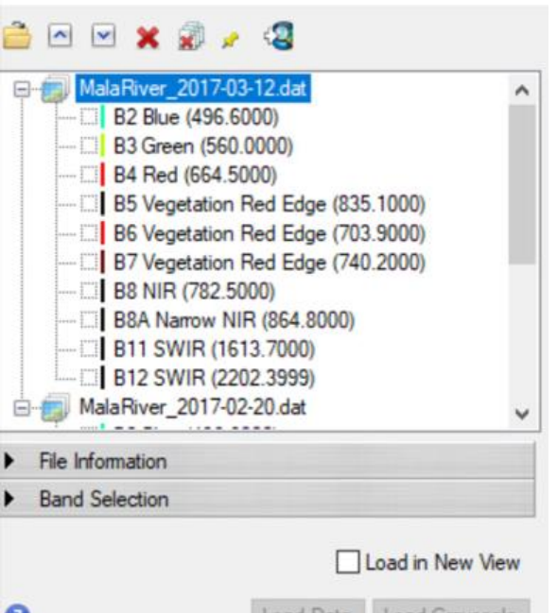

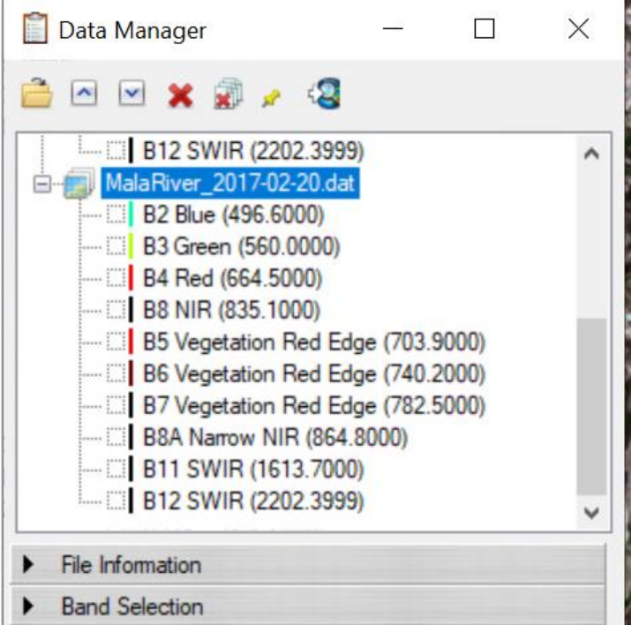

2. Describe how water "looks." Specifically, what differences do you notice in how water appears a) in different locations within each image ("through space") and b) at the same location between images ("through time"). What factors might explain the differences you describe?

Ans:

Through space (different places in one image)

* Rivers vs. lakes/ponds:  
  Rivers usually look darker because they are deeper and moving. Lakes or ponds can look lighter because they are shallow or have mud and dirt floating.
* Edges vs. middle of water:  
  Near the edges, the water looks lighter or brown because it’s shallow and mixed with soil or plants. In the middle, it looks darker (blue/black) because it is deeper and clearer.
* Shaded vs. sunny areas:  
  In shade, water looks darker. In sunlight, water can look shiny or bright from reflection.

Through time (same place before and after a flood)

* Before flood (Feb 20, 2017):  
  The river looks narrow and dark (normal water flow, less mud).
* After flood (Mar 12, 2017):  
  Water spreads over land, covering fields and roads.  
  The water looks lighter or muddy because floodwater carries soil and dirt.  
  Places that were dry before now look like water-covered areas.

Factors that explain these changes

1. Depth: Deep water = darker, shallow water = lighter.
2. Mud and dirt (sediment): More mud in water makes it look brown or cloudy.
3. Sunlight and shade: Sun makes water shiny; shade makes it dark.
4. Plants/vegetation: Plants in water can change their color.
5. Flood: The flood is the main reason—water becomes larger, spreads out, and looks muddier.

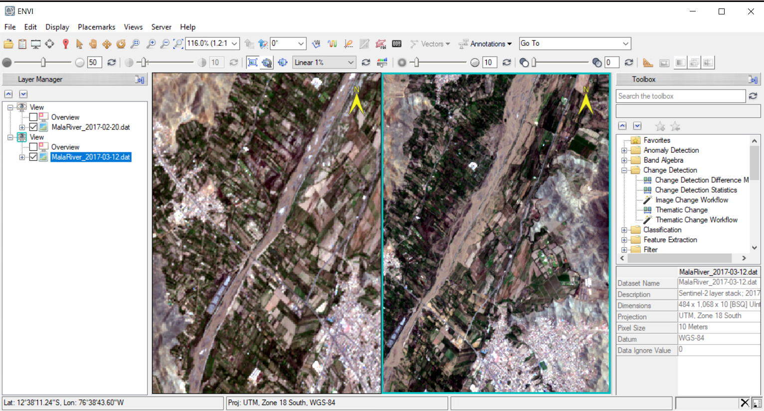

* 1. The above Images show the Image of the area before the flood and after the flood

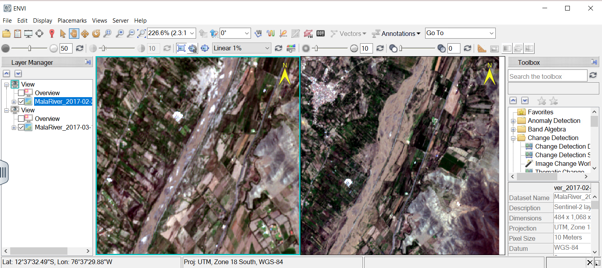

* 1. The above Image shows how water bodies look before and after floods.

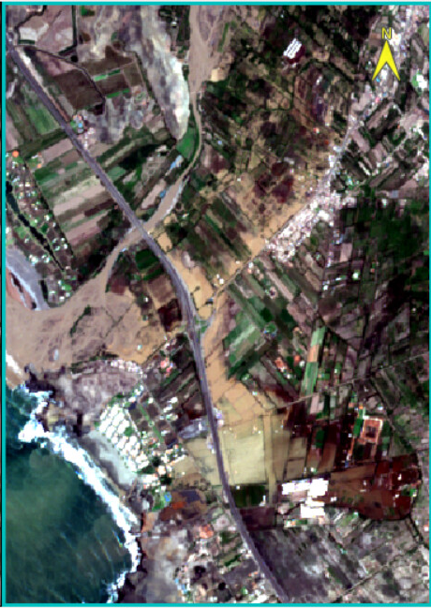

3.Image shows the detailed water bodies condition after flood.

3. Where do you notice the greatest changes in reflectance? (This need not be limited to water?

Ans: When a flood happens, the biggest changes are in the places that get covered by water.

* Before the flood, the land (soil, fields, or vegetation) reflects more light, so it looks brighter or greener.
* After the flood, the land was covered with muddy water. Muddy water reflects light differently – it looks duller and lighter brown, not as bright as before.
* green Vegetation may appear darker or washed out because it is damaged or submerged.
* In short, the flooded areas show the largest reflectance change, since dry land and crops are replaced by muddy water.

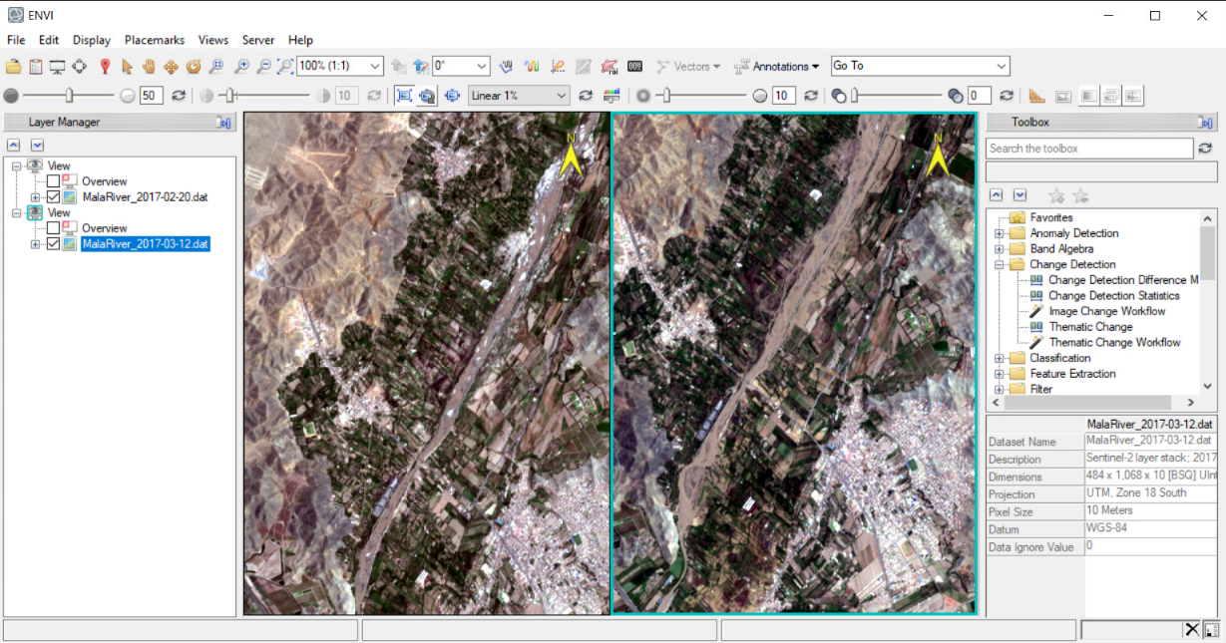

* 1. This Image shows the reflectance before and after the flood.

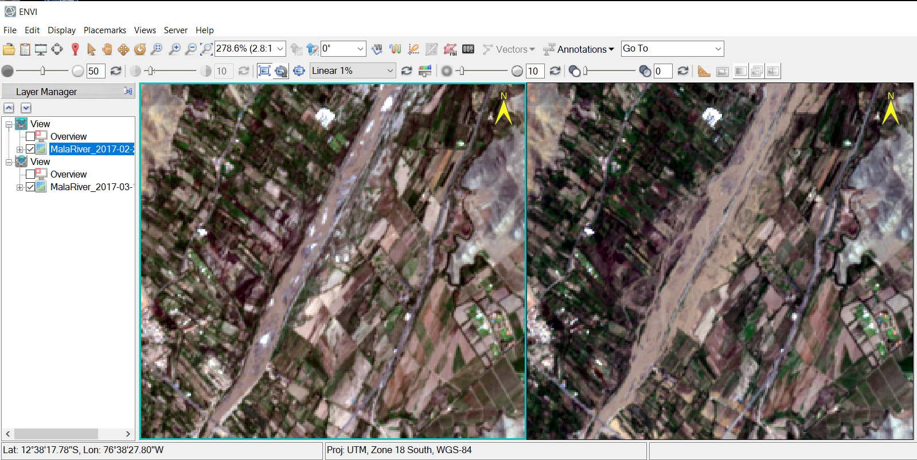

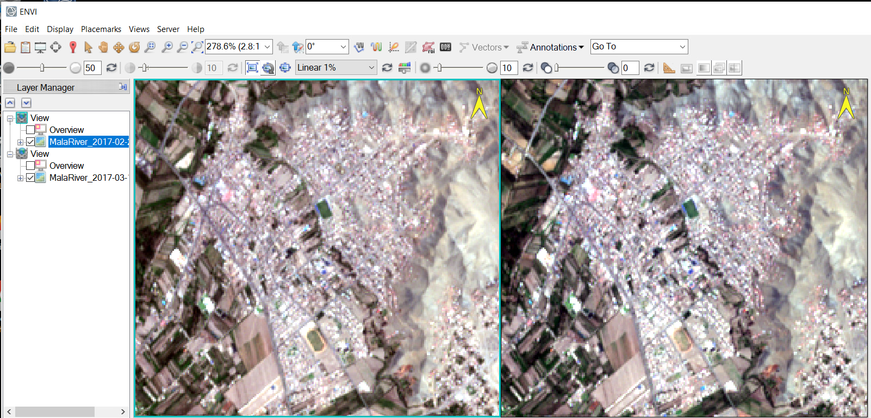

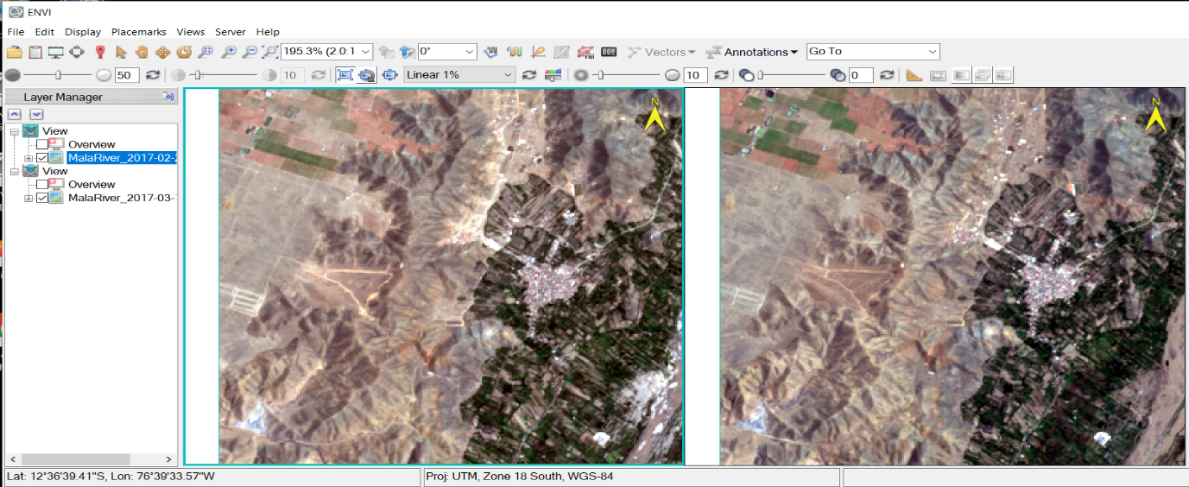

4.The above Images shows the reflectance before and after the flood of water bodies, trees, buildings etc.

4. How do your PCA results that describe the magnitude of change compare with the visual assessment of difference you made in response to Q3?

Ans:

* PCA highlights areas of the biggest change in an image by combining information from all bands.
* In the PCA image, areas with a high magnitude of change usually appear brighter, while areas with little change appear darker.
* In question no 3, visually we noticed that flooded areas show the greatest change in reflectance (muddy water, submerged land, damaged vegetation).
* PCA results should match this observation: the flooded regions will appear as bright areas in the PCA output, confirming that these areas experienced the most change.
* Any areas that didn’t flood (like deep water or undisturbed land) appear darker in PCA, which also agrees with the visual assessment.
* Sometimes visual differences are subtle, especially if water is slightly muddy or vegetation is partially affected.
* In the real image, you can see flooded areas and color changes. PCA results show these same areas clearly as bright regions, confirming and quantifying the magnitude of change.

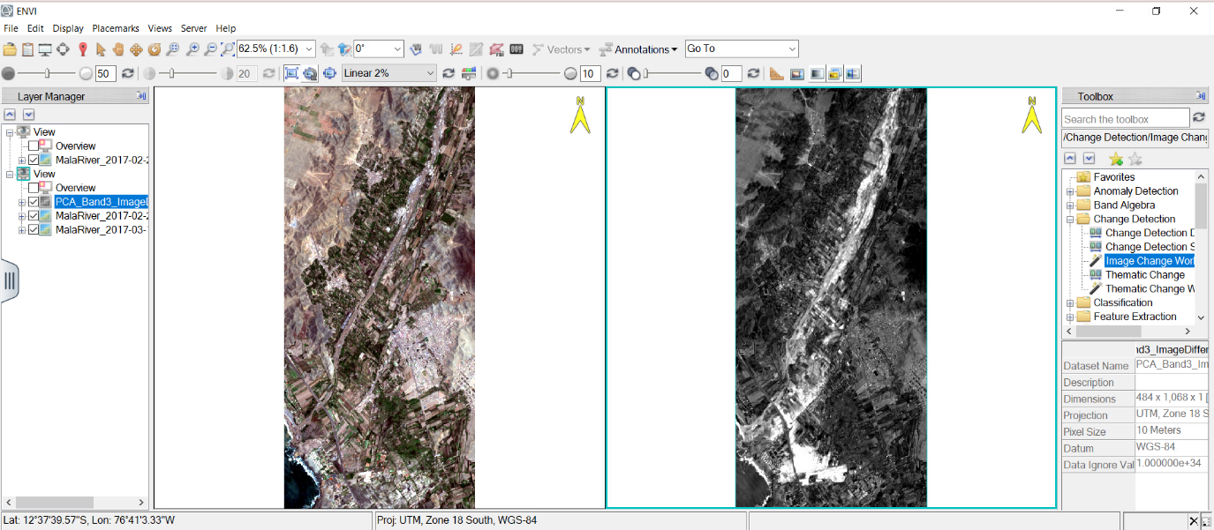

5. Image showing the before-flood image in normal and the post-flood image in PCA

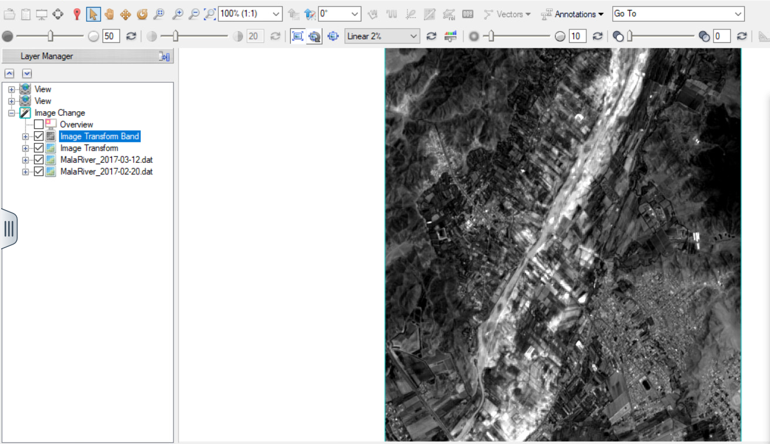

6. Detailed PCA Image

5.

* A black pixel means no change happened there.
* Example: Deep water in the river that stayed the same before and after the flood → it looks black because reflectance didn’t change much.
* Dark red means some change, but not very strong. Soil that became slightly wet, or vegetation that was a little damaged by water, shows a small-to-medium change in reflectance.
* Bright red means a big change happened. Dry farmland that got completely flooded, or green crops that got fully submerged strong change in reflectance, so the pixel is bright red.

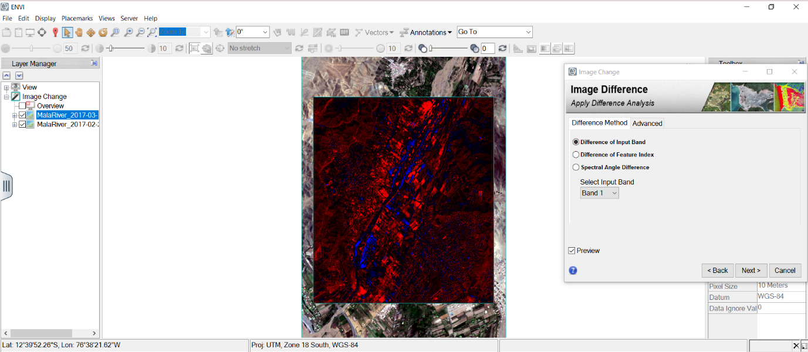

6.

* The first product (before refinement) probably shows more rough or general change areas. It might include some noise (extra pixels that look like change but aren’t real).
* The second product (after refinement) looks cleaner: the change areas are sharper, more accurate, and there are fewer false detections.
* First product (raw change map): Good for a quick overview. Shows all possible changes, but may include errors or “extra” changes.
* Second product (refined change map): More reliable for analysis. Removes noise and highlights the *true* change areas. Easier to interpret and use in reports or decision-making.

To refine means to improve the quality of the result by making it more accurate and removing unnecessary or false details.

refining makes the change detection map clearer, cleaner, and closer to reality.

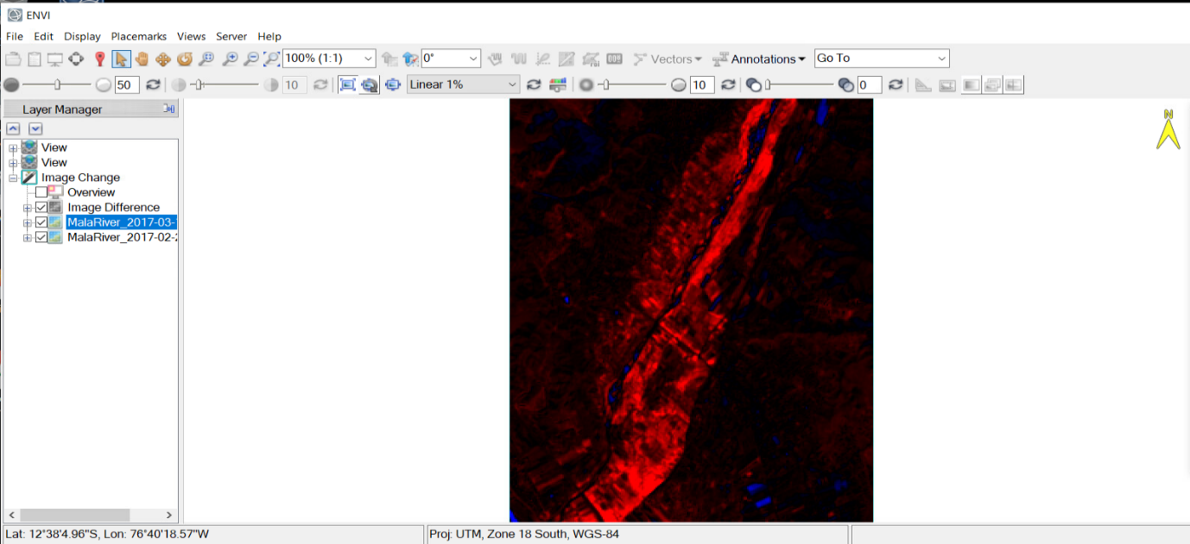

8.The above Image is before refinement.

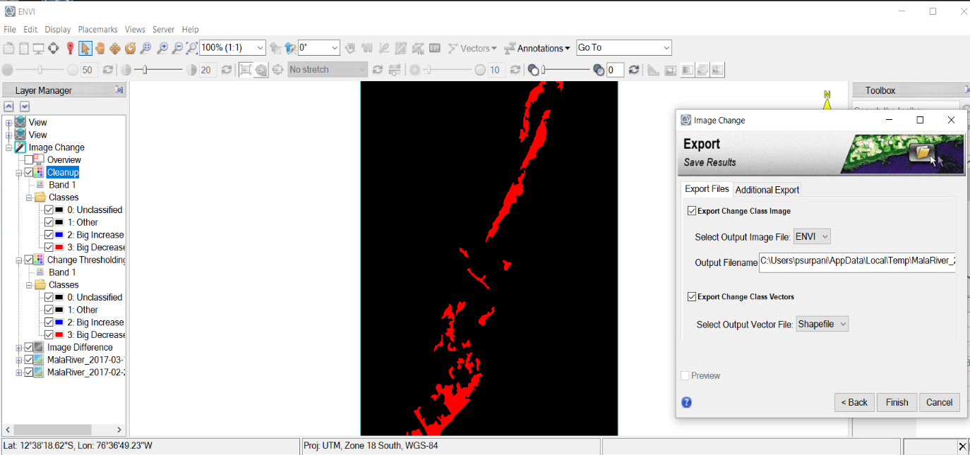

9.The above Image is after refinement.